**“Heart Disease Prediction”**

**A MINI PROJECT REPORT**

***Submitted by***

**Manchikanti Govindasai [RA2011003011265]**

**K.Venkata.Vamsi Krishna[RA2011003011291]**

**Vaddi Surya Ganesh[RA2011003011259]**

*Under the guidance of*

**Dr. Muralidharan C**

***In partial satisfaction of the requirements for the degree of***

**BACHELOR OF TECHNOLOGY**

in

**COMPUTER SCIENCE & ENGINEERING**



**SCHOOL OF COMPUTING**

**COLLEGE OF ENGINEERING AND TECHNOLOGY**

**SRM INSTITUTE OF SCIENCE AND TECHNOLOGY**

**KATTANKULATHUR - 603203**

**MAY 2023**



**Table of Contents**

ABSTRACT i

LIST OF FIGURES ii

LIST OF TABLES: iii

LIST OF ABBREVIATIONS iv

CHAPTER 1: INTRODUCTION 1

* 1. Problem Definition 1
  2. Motivation 1
  3. Objectives 2

CHAPTER 2: RELATED WORKS 3

CHAPTER 3: DATASETS 4

CHAPTER 4: METHODS AND ALGORITHMS USED 5

* 1. Logistic Regression 5
  2. Backward Elimination Method: 5
  3. Recursive Feature Elimination using Cross-Validation (RFECV) 6

CHAPTER 5: EXPERIMENTS 7

* 1. Data Preparation 7
  2. Exploratory Analysis 8
  3. Feature Selection 9
  4. Training and testing 10

CHAPTER 6: EVALUATION METRICS 11

* 1. Confusion Matrix 11
  2. Accuracy 11
  3. Recall 12
  4. Precision 12

CHAPTER 6: DISCUSSION ON RESULTS 13

CHAPTER 7: CONTRIBUTIONS 14

CHAPTER 9: CODE 15

* 1. Libraries used: 15

CHAPTER 10: CONCLUSION 16

# ABSTRACT

This report represents the mini-project assigned to seventh semester students, given by the department of computer science and engineering. Cardiovascular diseases are the most common cause of death worldwide over the last few decades in the developed as well as underdeveloped and developing countries. Early detection of cardiac diseases and continuous supervision of clinicians can reduce the mortality rate. However, it is not possible to monitor patients every day in all cases accurately and consultation of a patient for 24 hours by a doctor is not available since it requires more sapience, time and expertise. In this project, we have developed and researched about models for heart disease prediction through the various heart attributes of patient and detect impending heart disease using Machine learning techniques like backward elimination algorithm, logistic regression and REFCV on the dataset available publicly in Kaggle Website, further evaluating the results using confusion matrix and cross validation. The early prognosis of cardiovascular diseases can aid in making decisions on lifestyle changes in high risk patients and in turn reduce the complications, which can be a great milestone in the field of medicine.

*Keywords: Machine Learning, Logistic regression, Cross-Validation, Backward Elimination, REFCV, Cardiovascular Diseases.*

# LIST OF FIGURES:

Figure 1: Original Dataset Snapshot 4

Figure 2: Bar Graph of the Target Classes After Dropping 7

Figure 3: Bar Graph of the Target Classes Before Dropping 7

Figure 4: Dataset after Scaling and Imputing 7

Figure 5: Correlation Matrix Visualization 8

Figure 6: Result from Feature Selection using Backward Elimination Method 9

Figure 7: Dataset After Dropping Columns after Feature Selection 9

Figure 8: Top 10 important features supported by RFECV 10

# LIST OF TABLES:

Table 1: Confusion Matrix Obtained after training the data (feature selection by backward elimination) 11

Table 2: Confusion Matrix Obtained after training the data (feature selection by RFECV method)

....................................................................................................................................................... 11

Table 3: Comparison between the feature selection models after training and testing through LogisticRegression model 13

Table 4: Work Division 14

Table 5: Major modules and classes used from Sklearn 15

# LIST OF ABBREVIATIONS:

* + 1. IDE: Integrated Development Environment
    2. REFCV: Recursive Feature Elimination using Cross-Validation
    3. CV: Cross Validation
    4. RFE: Recursive Feature Elimination

# CHAPTER 1:

# INTRODUCTION

According to the World Health Organization, every year 12 million deaths occur worldwide due to Heart Disease. The load of cardiovascular disease is rapidly increasing all over the world from the past few years. Many researches have been conducted in attempt to pinpoint the most influential factors of heart disease as well as accurately predict the overall risk. Heart Disease is even highlighted as a silent killer which leads to the death of the person without obvious symptoms. The early diagnosis of heart disease plays a vital role in making decisions on lifestyle changes in high-risk patients and in turn reduce the complications. This project aims to predict future Heart Disease by analyzing data of patients which classifies whether they have heart disease or not using machine-learning algorithms.

## Problem Definition

The major challenge in heart disease is its detection. There are instruments available which can predict heart disease but either they are expensive or are not efficient to calculate chance of heart disease in human. Early detection of cardiac diseases can decrease the mortality rate and overall complications. However, it is not possible to monitor patients every day in all cases accurately and consultation of a patient for 24 hours by a doctor is not available since it requires more sapience, time and expertise. Since we have a good amount of data in today’s world, we can use various machine learning algorithms to analyze the data for hidden patterns. The hidden patterns can be used for health diagnosis in medicinal data.

## Motivation

Machine learning techniques have been around us and has been compared and used for analysis for many kinds of data science applications. The major motivation behind this research-based project was to explore the feature selection methods, data preparation and processing behind the training models in the machine learning. With first hand models and libraries, the challenge we face today is data where beside their abundance, and our cooked models, the accuracy we see during training, testing and actual validation has a higher variance. Hence this project is carried out with the motivation to explore behind the models, and further implement Logistic Regression

model to train the obtained data. Furthermore, as the whole machine learning is motivated to develop an appropriate computer-based system and decision support that can aid to early detection of heart disease, in this project we have developed a model which classifies if patient will have heart disease in ten years or not based on various features (i.e. potential risk factors that can cause heart disease) using logistic regression. Hence, the early prognosis of cardiovascular diseases can aid in making decisions on lifestyle changes in high risk patients and in turn reduce the complications, which can be a great milestone in the field of medicine.

## Objectives

The main objective of developing this project are:

* + 1. To develop machine learning model to predict future possibility of heart disease by implementing Logistic Regression.
    2. To determine significant risk factors based on medical dataset which may lead to heart disease.
    3. To analyze feature selection methods and understand their working principle.

# CHAPTER 2:

# RELATED WORKS

With growing development in the field of medical science alongside machine learning various experiments and researches has been carried out in these recent years releasing the relevant significant papers. The paper [1] propose heart disease prediction using KStar, J48, SMO, and Bayes Net and Multilayer perceptron using WEKA software. Based on performance from different factor SMO (89% of accuracy) and Bayes Net (87% of accuracy) achieve optimum performance than KStar, Multilayer perceptron and J48 techniques using k-fold cross validation. The accuracy performance achieved by those algorithms are still not satisfactory. So that if the performance of accuracy is improved more to give batter decision to diagnosis disease.

1. In a research conducted using Cleveland dataset for heart diseases which contains 303 instances and used 10-fold Cross Validation, considering 13 attributes, implementing 4 different algorithms, they concluded Gaussian Naïve Bayes and Random Forest gave the maximum accuracy of 91.2 percent.
2. Using the similar dataset of Framingham, Massachusetts, the experiments were carried out using 4 models and were trained and tested with maximum accuracy K Neighbors Classifier: 87%, Support Vector Classifier: 83%, Decision Tree Classifier: 79% and Random Forest Classifier: 84%.

# CHAPTER 3:

# DATASETS

The dataset is publicly available on the Kaggle Website at [4] which is from an ongoing cardiovascular study on residents of the town of Framingham, Massachusetts. It provides patient information which includes over 4000 records and 14 attributes. The attributes include: age, sex, chest pain type, resting blood pressure, serum cholesterol, fasting, sugar blood, resting electrocardiographic results, maximum heart rate, exercise induced angina, ST depression induced by exercise, slope of the peak exercise, number of major vessels, and target ranging from 0 to 2, where 0 is absence of heart disease. The data set is in csv (Comma Separated Value) format which is further prepared to data frame as supported by pandas library in python.

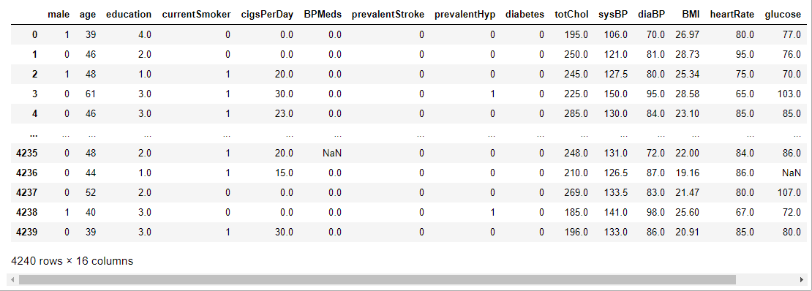

*Figure 1: Original Dataset Snapshot*

The education data is irrelevant to the heart disease of an individual, so it is dropped. Further with this dataset pre-processing and experiments are then carried out.

# CHAPTER 4: METHODS AND ALGORITHMS USED

The main purpose of designing this system is to predict the ten-year risk of future heart disease. We have used Logistic regression as a machine-learning algorithm to train our system and various feature selection algorithms like Backward elimination and Recursive feature elimination. These algorithms are discussed below in detail.

## Logistic Regression

Logistic Regression is a supervised classification algorithm. It is a predictive analysis algorithm based on the concept of probability. It measures the relationship between the dependent variable (TenyearCHD) and the one or more independent variables (risk factors) by estimating probabilities using underlying logistic function (sigmoid function). Sigmoid function is used as a cost function to limit the hypothesis of logistic regression between 0 and 1 (squashing) i.e. 0 ≤ hθ (x) ≤ 1.

In logistic regression cost function is defined as:

𝐶𝑜𝑠𝑡(hθ(x), y) = {

− log(ℎ𝜃(𝑥)) 𝑖𝑓 𝑦 = 1

− log(1 − ℎ𝜃(𝑥)) 𝑖𝑓 𝑦 = 0

Logistic Regression relies highly on the proper presentation of data. So, to make the model more powerful, important features from the available data set are selected using Backward elimination and recursive elimination techniques.

## Backward Elimination Method:

While building a machine learning model only the features which have a significant influence on the target variable should be selected. In the backward elimination method for feature selection, the first step is selecting a significance level or P-value. For our model, we have chosen a 5% significance level or P-value of 0.05. The feature with high P-value is identified, and if its P-value is greater than the significance level it is removed from the dataset. The model is fit again with a new dataset, and the process is repeated till all remaining features in dataset is less than the significance level. In this model, factors male, age, cigsPerDay, prevalentStroke, diabetes, and sysBP were chosen as significant ones after using the backward elimination algorithm.

## Recursive Feature Elimination using Cross-Validation (RFECV)

RFECV is greedy optimization algorithm which aims to find the best performing feature subset. Recursive Feature Elimination (RFE) fits a model repeatedly and removes the weakest feature until specified number of features is reached. The optimal number of features is used with RFE to score different feature subsets and select the best scoring collection of features which is RFECV. The main issue of this algorithm is that it can be expensive to run. So, it is better to reduce the number of features beforehand. Since correlated features provide the same information, such features can be eliminated prior to RFECV. To address this, correlation matrix is plotted and the correlated features are removed.

The arguments for instance of RFECV are:

* + 1. estimator - model instance (RandomForestClassifier)
    2. step - number of features removed on each iteration (1)
    3. cv – Cross-Validation (StratifiedKFold)
    4. scoring – scoring metric (accuracy)

Once RFECV is run and execution is finished, the features that are least important can be extracted and dropped from the dataset. Top 10 features ranked by the RFECV technique in our model listed below from least importance to highest importance.

1. prevalentStroke
2. diabetes
3. BPMeds
4. currentSmoker
5. prevalentHyp
6. male
7. cigsPerDay
8. heartrate
9. glucose
10. diaBP

# CHAPTER 5: EXPERIMENTS

## Data Preparation

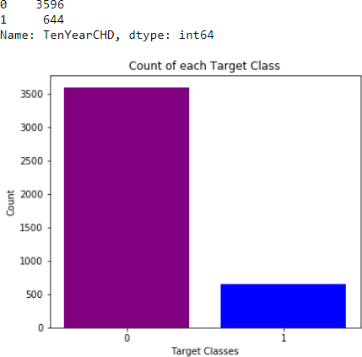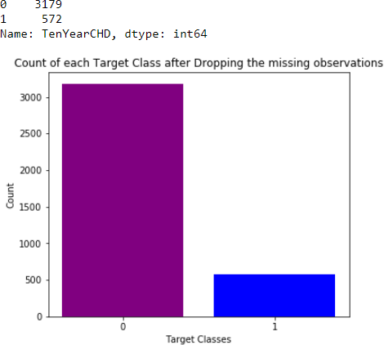Since the dataset consists of 4240 observations with 388 missing data and 644 observations to be risked for heart disease, two different experiments were performed for data preparation. First, we checked by dropping the missing data, leaving with only 3751 data and only 572 observations risked for heart disease.

*Figure 2: Bar Graph of the Target Classes before Dropping*

*Figure 3: Bar Graph of the Target Classes after Dropping*

*Figure 3: Bar Graph of the Target Classes Before Dropping Figure 2: Bar Graph of the Target Classes After Dropping*

This leads to reduced number of the observations providing irrelevant training to our model. So, we progressed with imputation of data with the mean value of the observations and scaling them using SimpleImputer and StandardScaler modules of Sklearn.

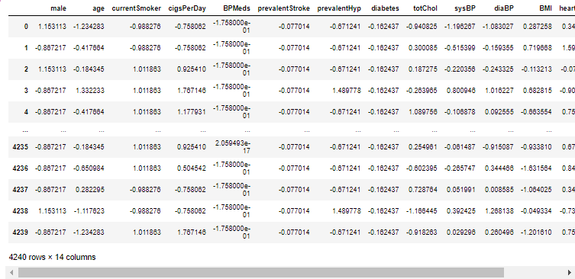

*Figure 4: Dataset after Scaling and Imputing*

## Exploratory Analysis:

Correlation Matrix visualization Before Feature Selection shows

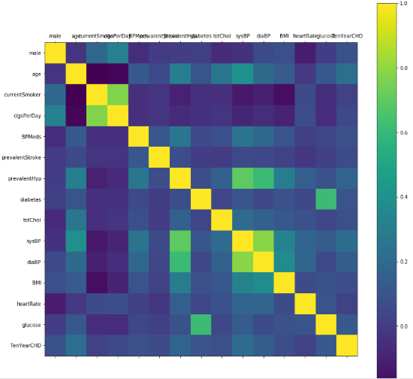

*Figure 5: Correlation Matrix Visualization*

It shows that there is no single feature that has a very high correlation with our target value. Also, some of the features have a negative correlation with the target value and some have positive. The data was also visualized through plots and bar graphs.

## Feature Selection

### Feature Selection using Backward Elimination (P-value) algorithm:

Further the data was passed through the backward elimination function to select the most relevant features which gave following result:

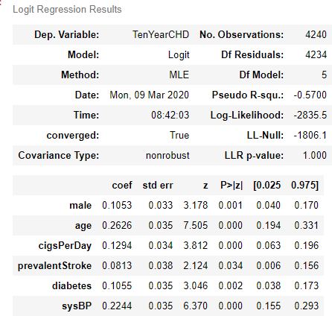

*Figure 6: Result from Feature Selection using Backward Elimination Method*

According the result above the columns were dropped.

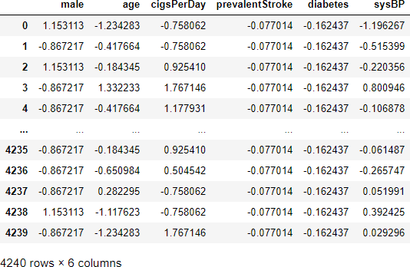

*Figure 7: Dataset After Dropping Columns after Feature Selection*

### Feature Selection using Recursive Feature Elimination and Cross-Validated selection method:

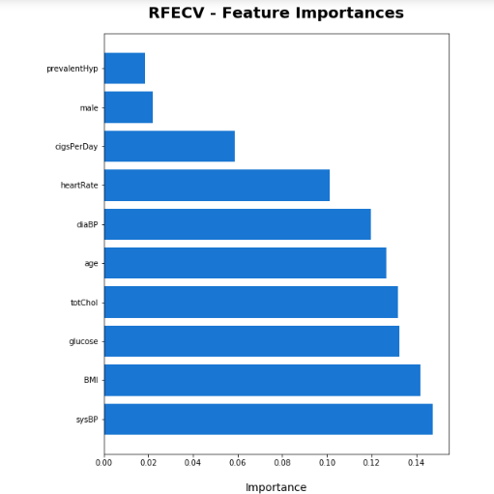

*Figure 8: Top 10 important features supported by RFECV*

## Training and testing

Finally, this resulting data split into 80% train and 20% test data, which was further passed to the LogisticRegression model to fit, predict and score the model.

# CHAPTER 6:

# EVALUATION METRICS

For the evaluation of our output from our training the data, the accuracy was analyzed

“Confusion matrix”.

## Confusion Matrix

A confusion matrix, also known as an error matrix, is a table that is often used to describe the performance of a classification model (or “classifier”) on a set of test data for which the true values are known. It allows the visualization of the performance of an algorithm. It allows easy identification of confusion between classes e.g. one class is commonly mislabeled as the other. The key to the confusion matrix is the number of correct and incorrect predictions are summarized with count values and broken down by each class not just the number of errors made.

|  |  |
| --- | --- |
| TP=3569 | FP=27 |
| FN=599 | TN=45 |

*Table 1: Confusion Matrix Obtained after training the data (feature selection by backward elimination)*

|  |  |
| --- | --- |
| TP=3582 | FP=14 |
| FN=600 | TN=44 |

*Table 2: Confusion Matrix Obtained after training the data (feature selection by RFECV method)*

## Accuracy

The accuracy is calculated as:

Where,

Accuracy =

𝑇𝑃+𝑇𝑁

𝑇𝑃+𝑇𝑁+𝐹𝑃+𝐹𝑁

* + - True Positive (TP) =Observation is positive, and is predicted to be positive.
    - False Negative (FN) = Observation is positive, but is predicted negative.
    - True Negative (TN) = Observation is negative, and is predicted to be negative.
    - False Positive (FP) =Observation is negative, but is predicted positive

The obtained accuracy during training the data after feature selection using backward elimination was 86 % and during testing was 83%.

The obtained accuracy during training the data after feature selection using REFCV method was 86 % and during testing was 85 %.

## Recall

Recall can be defined as the ratio of the total number of correctly classified positive examples divide to the total number of positive examples. High Recall indicates the class is correctly recognized (a small number of FN). Recall is calculated as:

Recall =

𝑇𝑃

𝑇𝑃+𝐹𝑁

The obtained recall during training the data after feature selection using backward elimination was and during testing was 0.99.

The obtained recall during training the data after feature selection using REFCV method was 1.00 and during testing was 0.99.

## Precision

To get the value of precision we divide the total number of correctly classified positive examples by the total number of predicted positive examples. High Precision indicates an example labelled as positive is indeed positive (a small number of FP). Precision is calculated as:

𝑇𝑃

Precision =

𝑇𝑃+𝐹𝑃

The obtained precision during training the data after feature selection using backward elimination was 0.86 and during testing was 0.84.

The obtained precision during training the data after feature selection using REFCV method and during testing was 0.86.

# CHAPTER 6:

# DISCUSSION ON RESULTS

When performing various methods of feature selection, testing it was found that backward elimination gave us the best results among others. The various methods tried were Backward Elimination with and without KFold, Recursive Feature Elimination with Cross Validation. The accuracy that was seen in them ranged around 85% with 85.5% being maximum. Though both methods gave similar accuracy but it was seen that in Backward Elimination we found that the number of misclassifications of True Negative was more and it was observed that the accuracy had more variance compared to RFEV. The precision of Backward Elimination and RFEV are 84% and 86% respectively. And the recalls are 0.99 and 1 respectively. The precision and recall also shows that the number of misclassifications is less in RFECV than in Backward Elimination.

|  |  |  |
| --- | --- | --- |
| Evaluation Metrics | Backward Elimination | RFECV |
| Accuracy | 83% | 85% |
| Recall | 0.99 | 0.99 |
| Precision | 0.84 | 0.86 |

*Table 3: Comparison between the feature selection models after training and testing through LogisticRegression model*

# CHAPTER 7:

# CONTRIBUTIONS

|  |  |  |  |
| --- | --- | --- | --- |
| Members  Task | M Govindasai | Vamsi Krishna | Surya Ganesh |
| Data Imputation and  Scaling |  |  |  |
| Data Cleaning |  |  |  |
| Exploratory Analysis |  |  |  |
| Feature Selection |  |  |  |
| Building Model |  |  |  |
| Result analysis and  Accuracy Test |  |  |  |
| Documentation |  |  |  |

*Table 4: Work Division*

# CHAPTER 9: CODE

The coding portion were carried out to prepare the data, visualize it, pre-process it, building the model and then evaluating it. The code has been written in Python programming language using Jupyter Notebook as IDE. The experiments and all the models building are done based on python libraries.

**import** pandas **as** pd

**import** numpy **as** np

**from** matplotlib **import** pyplot **as** plt

**import** scipy.stats **as** st

**import** statsmodels.api **as** sm

**from** matplotlib **import** rcParams

**from** matplotlib.pyplot **import** matshow

data_frame **=** pd**.**read_csv('framingham.csv')

df **=** pd**.**DataFrame(data_frame)

df_pre**=**pd**.**DataFrame(data_frame)

df

df**.**isnull()

df**.**isnull()**.**sum()

df**.**drop(['education'], axis **=** 1, inplace **=** **True**)

df**.**size

df**.**shape

df**.**head()

df**.**isnull()**.**sum()

rcParams['figure.figsize'] **=** 6,5

plt**.**bar(df**.**TenYearCHD**.**unique(), df**.**TenYearCHD**.**value_counts(), color **=** ['purple', 'blue'])

plt**.**xticks([0, 1])

plt**.**xlabel('Target Classes')

plt**.**ylabel('Count')

plt**.**title('Count of each Target Class')

print(df**.**TenYearCHD**.**value_counts())

df_test**=**df

df_test**.**dropna(axis**=**0,inplace**=True**)

df_test**.**shape

rcParams['figure.figsize'] **=** 6,5

plt**.**bar(df_test**.**TenYearCHD**.**unique(), df_test**.**TenYearCHD**.**value_counts(), color **=** ['purple', 'blue'])

plt**.**xticks([0, 1])

plt**.**xlabel('Target Classes')

plt**.**ylabel('Count')

plt**.**title('Count of each Target Class after Dropping the missing observations')

print(df_test**.**TenYearCHD**.**value_counts())

data_frame **=** pd**.**read_csv('framingham.csv')

df **=** pd**.**DataFrame(data_frame)

df**.**drop(['education'], axis **=** 1, inplace **=** **True**)

df**.**shape

cols**=**["male","age","currentSmoker","cigsPerDay","BPMeds","prevalentStroke","prevalentHyp","diabetes","totChol","sysBP","diaBP","BMI","heartRate"]

X_components**=**df**.**columns[:**-**1]

ddf**=**df[X_components]

ddf

pipe1**=**Pipeline([("imputer",SimpleImputer(strategy**=**"mean")),("scaler",StandardScaler())])

df1**=**pipe1**.**fit_transform(ddf)

df_mean**=**pd**.**DataFrame(data**=**df1[0:,0:], columns**=**cols)

pipe2**=**Pipeline([("imputer",SimpleImputer(strategy**=**"median")),("scaler",StandardScaler())])

df2**=**pipe1**.**fit_transform(ddf)

df_median**=**pd**.**DataFrame(data**=**df2[0:,0:], columns**=**cols)

pipe3**=**Pipeline([("imputer",SimpleImputer(strategy**=**"most_frequent")),("scaler",StandardScaler())])

df3**=**pipe1**.**fit_transform(ddf)

df_most**=**pd**.**DataFrame(data**=**df3[0:,0:], columns**=**cols)

*#imp1=SimpleImputer(strategy="mean")*

*#imp2=SimpleImputer(strategy="median")*

*#imp3=SimpleImputer(strategy="most_frequent")*

df_mean**.**shape

df_mean

**from** ipywidgets **import** widgets

feature_desc**=**{'age':'Age of person',

'cigsPerDay':'No of average ciggarete taken per day',

'BPMeds':'BPMeds',

'prevalentStroke':'prevalentStroke',

'prevalentHype':'prevalentHype',

'diabetes':'diabetes',

'totChol':'Total Cholesterol Value Measured',

'sysBP':'sysBP',

'diaBP':'diaBP',

'BMI':'Body Mass Index',

'heartRate':'Heart Rate',

'glucose':'Glucose',

'TenYearCHD':'Ten Year CHD'}

**def** hist_feature(column):

df[column]**.**hist(bins**=**20,facecolor**=**'midnightblue')

plt**.**show()

dropdown_menu **=** {v:k **for** k,v **in** feature_desc**.**items()}

widgets**.**interact(hist_feature, column**=**dropdown_menu)

**from** matplotlib **import** rcParams

**from** matplotlib.pyplot **import** matshow

rcParams['figure.figsize'] **=** 3,8

plt**.**matshow(df**.**corr())

plt**.**yticks(np**.**arange(df_mean**.**shape[1]), df**.**columns)

plt**.**xticks(np**.**arange(df_mean**.**shape[1]), df**.**columns)

plt**.**colorbar()

rcParams['figure.figsize'] **=** 8,6

plt**.**bar(df**.**TenYearCHD**.**unique(), df**.**TenYearCHD**.**value_counts(), color **=** ['purple', 'blue'])

plt**.**xticks([0, 1])

plt**.**xlabel('Target Classes')

plt**.**ylabel('Count')

plt**.**title('Count of each Target Class')

df_mean**.**describe()

**def** draw_histograms(dataframe, features, rows, cols):

fig**=**plt**.**figure(figsize**=**(20,20))

**for** i, feature **in** enumerate(features):

ax**=**fig**.**add_subplot(rows,cols,i**+**1)

dataframe[feature]**.**hist(bins**=**20,ax**=**ax,facecolor**=**'midnightblue')

ax**.**set_title(feature**+**" Distribution",color**=**'DarkRed')

fig**.**tight_layout()

plt**.**show()

draw_histograms(df,df**.**columns,6,3)

**from** sklearn.linear_model **import** LogisticRegression

**from** sklearn.feature_selection **import** RFE, RFECV, SelectFromModel

**from** sklearn.ensemble **import** RandomForestClassifier

**from** sklearn.model_selection **import** StratifiedKFold, train_test_split

**from** sklearn.utils **import** shuffle

**from** sklearn.metrics **import** confusion_matrix,accuracy_score,classification_report

**from** statsmodels.tools **import** add_constant

df_constant **=** add_constant(df)

df_constant**.**head()

X1_components**=**df_mean**.**columns

X1**=**df_mean[X1_components]

y1**=**df**.**TenYearCHD

X2_components**=**df_median**.**columns

X2**=**df_median[X2_components]

y2**=**df**.**TenYearCHD

X1**.**shape

column_list**=**['male','age','currentSmoker','cigsPerDay' ,'BPMeds','prevalentStroke','prevalentHyp' ,'diabetes', 'totChol', 'sysBP', 'diaBP', 'BMI']

df_mean**.**isnull()**.**sum()

**def** feature_selection(data_frame, dependent_variable, column_list):

**while** len(column_list)**>**0:

model **=** sm**.**Logit(dependent_variable, data_frame[column_list])

result **=** model**.**fit(disp **=** 0)

largest_pvalue **=** round(result**.**pvalues, 3)**.**nlargest(1)

**if** largest_pvalue[0] **<** (0.05):

**return** result

**break**

**else**:

column_list **=** column_list**.**drop(largest_pvalue**.**index)

cols **=** df_mean**.**columns[:**-**1]

result1 **=** feature_selection(df_mean, y1, cols)

print("This is the result using the imputation for mean values")

result1**.**summary()

**from** matplotlib **import** rcParams

**from** matplotlib.pyplot **import** matshow

column_list**=**["male","age","cigsPerDay","prevalentStroke","diabetes","sysBP"]

new**=**df_mean[column_list]

rcParams['figure.figsize'] **=** 20, 14

plt**.**matshow(new**.**corr())

plt**.**yticks(np**.**arange(new**.**shape[1]), df**.**columns)

plt**.**xticks(np**.**arange(new**.**shape[1]), df**.**columns)

plt**.**colorbar()

result2 **=** feature_selection(df_median, y2, cols)

print("This is the result using the imputation for median values")

result2**.**summary()

column_list**=**["male","age","cigsPerDay","prevalentStroke","diabetes","sysBP"]

X**=**df_mean[column_list]

y**=**df**.**TenYearCHD

X_train,X_test,y_train,y_test**=**train_test_split(**\***shuffle(X,y), test_size**=**0.2, random_state**=**5)

log_model**=**LogisticRegression()

log_model**.**fit(X_train,y_train)

df_mean**.**columns

X**.**columns

X_components**=**df_mean**.**columns

X**=**df_mean[X_components]

rfecv_array **=** [**True**, **True**, **False**,**True**,**False**,**False**,**True**,**False**,**True**,**True**,**True**,**True**,**True**,**True**]

res **=** [i **for** i, val **in** enumerate(rfecv_array) **if** **not** val]

X**.**drop(X**.**columns[res], axis**=**1, inplace**=True**)

In [72]:

X_train,X_test,y_train,y_test**=**train_test_split(**\***shuffle(X,y),

test_size**=**0.2,

random_state**=**5)

log_model**=**LogisticRegression()

log_model**.**fit(X_train,y_train)

log_model**.**score(X_train,y_train)

rfecv**.**estimator_**.**feature_importances_

X_components**=**df**.**columns[:**-**1]

X**=**df[X_components]

dset **=** pd**.**DataFrame()

dset['attr'] **=** X**.**columns

dset['importance'] **=** rfecv**.**estimator_**.**feature_importances_

dset **=** dset**.**sort_values(by**=**'importance', ascending**=False**)

plt**.**figure(figsize**=**(16, 14))

plt**.**barh(y**=**dset['attr'], width**=**dset['importance'], color**=**'#1976D2')

plt**.**title('RFECV - Feature Importances', fontsize**=**20, fontweight**=**'bold', pad**=**20)

plt**.**xlabel('Importance', fontsize**=**14, labelpad**=**20)

plt**.**show()

X_components**=**df**.**columns[:**-**1]

X**=**df[X_components]

y**=**df**.**TenYearCHD

In [35]:

X_train, X_test, y_train, y_test**=** train_test_split(X, y, random_state **=** 0)

logreg **=** LogisticRegression(fit_intercept **=** **False**)

logreg**.**fit(X_train, y_train)

*# print(np.where(rfecv.support_ == False)[0])*

coefficient_array **=** [ **True**, **True**, **False**, **True**, **True**, **True**, **True**, **True**, **False**,**True**, **False**, **False**, **False**, **False**]

res **=** [i **for** i, val **in** enumerate(coefficient_array) **if** **not** val]

X**.**drop(X**.**columns[res], axis**=**1, inplace**=True**)

X

X_components**=**df**.**columns[:**-**1]

X**=**df[X_components]

y**=**df**.**TenYearCHD

X_train, X_test, y_train, y_test**=** train_test_split(X, y, random_state **=** 0)

In [44]:

predictors **=** X_train

selector **=** RFE(logreg, n_features_to_select **=** 1)

selector **=** selector**.**fit(predictors, y_train)

order **=** selector**.**ranking_

order

feature_ranks **=** []

**for** i **in** order:

feature_ranks**.**append(f"{i}.{df**.**columns[i]}")

feature_ranks

X_components**=**df**.**columns[:**-**1]

X**=**df[X_components]

y**=**df**.**TenYearCHD

X_train, X_test, y_train, y_test**=** train_test_split(X, y, random_state **=** 0)

smf **=** SelectFromModel(logreg, threshold **=** **-**np**.**inf, max_features **=** 8)

smf**.**fit(X_train, y_train)

sfm_array **=**[ **True**, **True**, **True**, **False**, **True**, **False**, **True**, **True**, **False**,**False**, **True**, **True**, **False**, **False**]

res **=** [i **for** i, val **in** enumerate(sfm_array) **if** **not** val]

X**.**drop(X**.**columns[res], axis**=**1, inplace**=True**)

**def** separate_by_class(dataset):

separated **=** dict()

**for** i **in** range(len(dataset)):

vector **=** dataset[i]

class_value **=** vector[**-**1]

**if** (class_value **not** **in** separated):

separated[class_value] **=** list()

separated[class_value]**.**append(vector)

**return** separated

In [60]:

separate_by_class(df)

## Libraries used:

* + 1. NumPy
    2. SciPy
    3. Matplotlib (pyplot, rcparams, matshow)
    4. Statsmodels
    5. Pandas
    6. Tkinter
    7. Sklearn

|  |  |
| --- | --- |
| **Modules used:** | **Imported class from respective modules:** |
| a. Sklearn.impute | SimpleImputer |
| b. Sklearn.preprocessing | StandardScaler |
| c. Sklearn.pipeline | Pipeline |
| d. Sklearn.feature_selection | RFECV |
| e. Sklearn.ensemble | RandomForestClassifier |
| f. Sklearn.model_selection | Train_test_split, StratifiedKFold |
| g. Sklearn.linear_model | LogisticRegression, |
| h. Sklearn.utils | Shuffle |
| i. Sklearn.metrics | Accuracy_score, confusion_matrix |

*Table 5: Major modules and classes used from Sklearn*

# CHAPTER 10:

# CONCLUSION

The early prognosis of cardiovascular diseases can aid in making decisions on lifestyle changes in high risk patients and in turn reduce the complications, which can be a great milestone in the field of medicine. This project resolved the feature selection i.e. backward elimination and RFECV behind the models and successfully predict the heart disease, with 85% accuracy. The model used was Logistic Regression. Further for its enhancement, we can train on models and predict the types of cardiovascular diseases providing recommendations to the users, and also use more enhanced models.

# REFERENCES

1. A. H. M. S. U. Marjia Sultana, "Analysis of Data Mining Techniques for Heart Disease Prediction," 2018.
2. M. I. K. ,. A. I. ,. S. Musfiq Ali, "Heart Disease Prediction Using Machine Learning Algorithms".
3. K. Bhanot, "towarddatascience.com," 13 Feb 2019. [Online]. Available: https://towardsdatascience.com/predicting-presence-of-heart-diseases-using-machine- learning-36f00f3edb2c. [Accessed 2 March 2020].
4. [Online]. Available: https://[www.kaggle.com/ronitf/heart-disease-uci#heart.csv..](http://www.kaggle.com/ronitf/heart-disease-uci#heart.csv) [Accessed 05 December 2019].
5. M. A. K. S. H. K. M. a. V. P. M Marimuthu, "A Review on Heart Disease Prediction using Machine Learning and Data Analytics Approach".